**PART 2 – DESIGN & BUILD E-COMMERCE WEBSITE**

# 

# EcoElevate E-Commerce

## Desktop Device

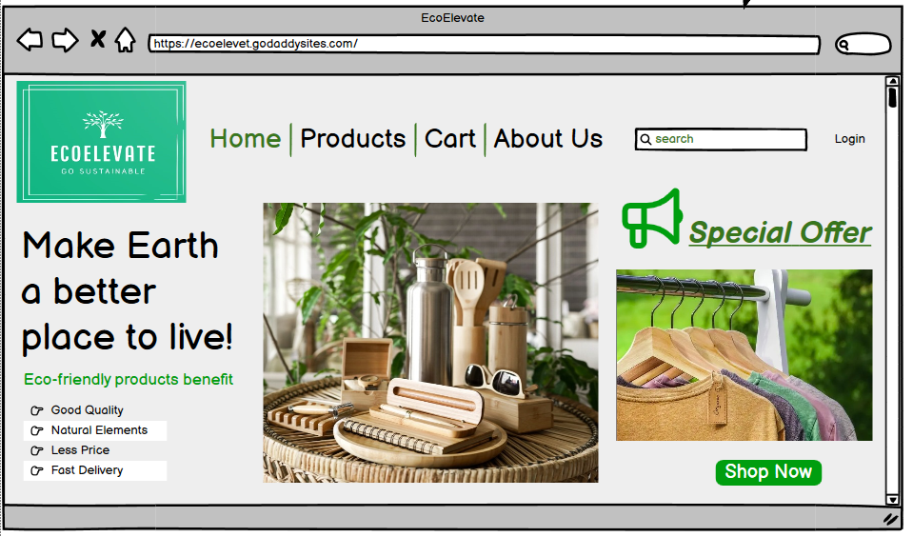

Fig: Home Page

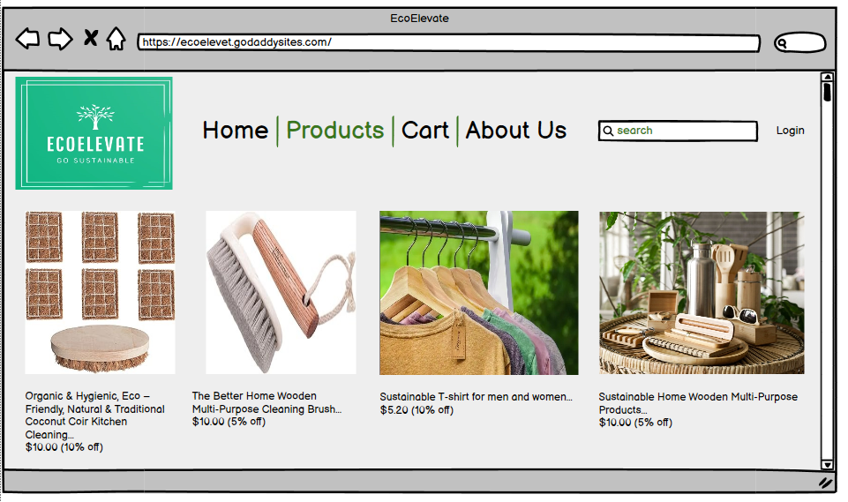

Fig: Products Page

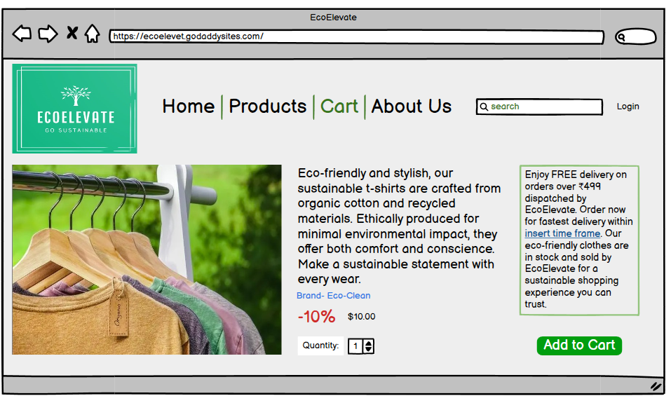

Fig: Cart Page

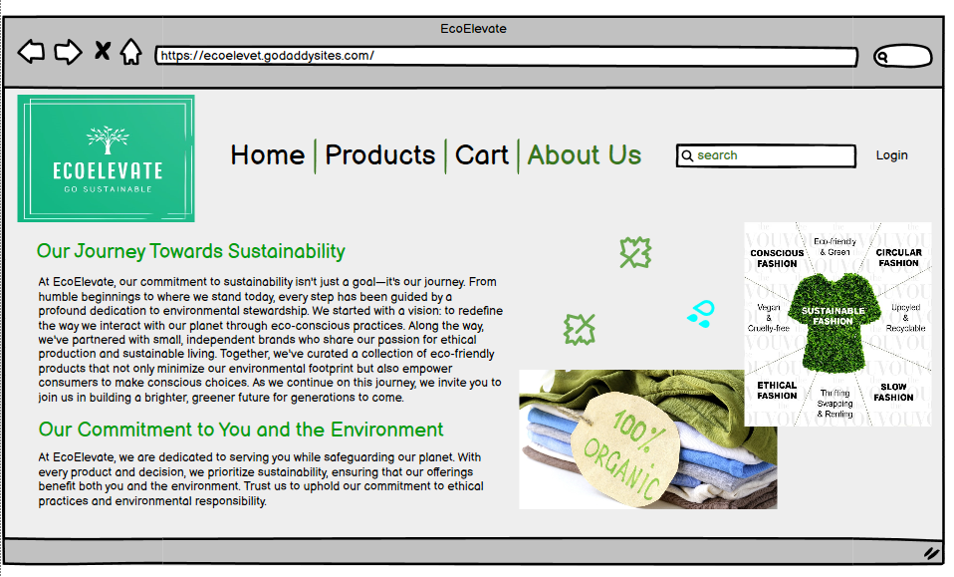

Fig: About Us Page

The picked life systems for the work area gadget construction of our internet business site are designed to advance the client experience and work with simple navigation. Here is the legitimization:

* Responsive Design: The site layout is responsive, guaranteeing similarity across different work area screen sizes and goals. This guarantees a consistent perusing experience for clients no matter what their gadget particulars.
* Clear Navigation: The navigation menu is conspicuously shown, including the instinctive order of items and simple admittance to fundamental pages like home, item classes, truck, and checkout. This works with productive investigation and navigation for clients, upgrading ease of use.
* Visual Ordered progression: The layout follows a reasonable visual progressive system, with key components like the legend pennant, included items and source of inspiration fastens decisively positioned to catch consideration and guide clients towards wanted activities, like item investigation and buying.
* Drawing in Content: Convincing visuals and concise, informative content are utilized all through the site to connect with clients and pass on key messages actually. This incorporates great item pictures, brief item depictions, and powerful duplicates to feature the incentive of our eco-friendly items.
* Noticeable CTAs: Clear and unmistakable invitations to take action (CTAs) are decisively positioned all through the site, empowering clients to make a move, for example, adding items to their trucks or continuing to checkout. This smoothes out the buying system and drives changes.
* Trust Signs: Trust signals, for example, client surveys, security identifications, and brand supports, are consolidated to impart trust in clients and reduce any worries they might have about making a buy. This helps assemble validity and confidence in our image and items.

By and large, the picked life systems for the work area gadget construction of our internet business site are designed to focus on client experience, work with proficient navigation, and drive transformations by really displaying our eco-friendly items and empowering activity from clients.

## Mobile Device

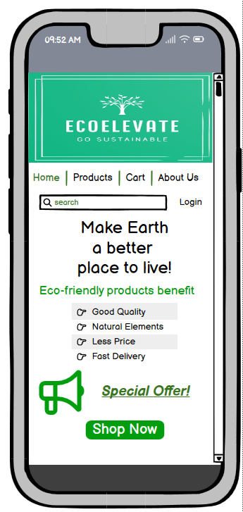

Fig: Home Page

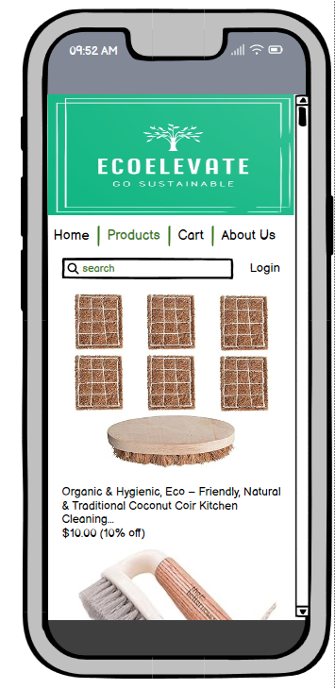

Fig: Products Page

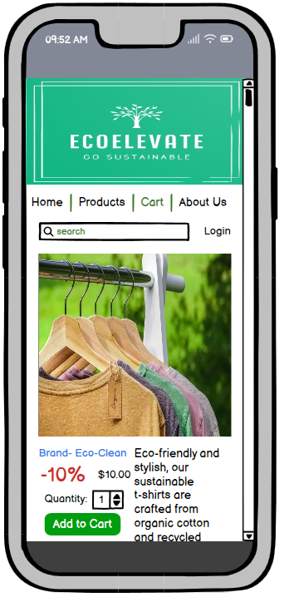

Fig: Cart Page

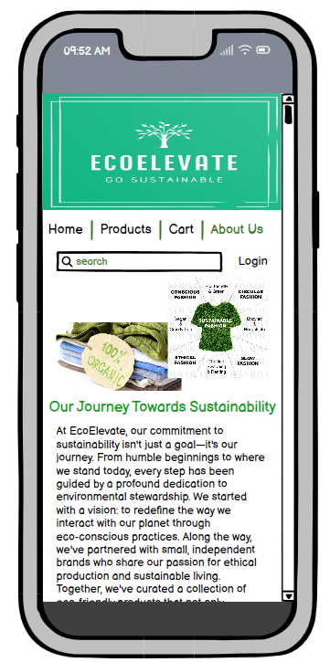

Fig: About Us Page

The decision of anatomy for the mobile gadget structure of our online business site is meticulously designed to guarantee ideal convenience and consistent navigation. Here is the defence:

* Mobile-Friendly Design: The site is designed with a mobile-first methodology, guaranteeing that it is completely responsive and upgraded for more modest screens. This takes into consideration a steady and easy-to-use insight across different mobile gadgets, taking care of the rising number of clients perusing and shopping on cell phones and tablets.
* Simplified Navigation: Given the restricted screen space on mobile gadgets, the navigation menu is consolidated into a cheeseburger menu symbol, rationing space while as yet giving admittance to fundamental navigation joins. This smoothed-out approach diminishes mess and makes it simpler for clients to find what they're searching for.
* Thumb-Friendly Interaction: Intelligent components, for example, fastens and connects are decisively positioned inside simple reach of the client's thumb, working with easy tapping and navigation. This guarantees an agreeable and instinctive perusing experience without expecting clients to extend or change their hold.
* Vertical Scrolling: The content layout is advanced for vertical scrolling, permitting clients to handily swipe and look at item postings, classifications, and other content without the requirement for level scrolling or zooming. This advances effective investigation and revelation of items on mobile gadgets.
* Concise Content: Content is introduced in a concise and searchable format, with clear item pictures, brief portrayals, and conspicuous source of inspiration buttons. This guarantees that clients can rapidly survey items and pursue informed choices without being overpowered by exorbitant text or jumbled layouts.
* Fast Loading Speed: Mobile advancement incorporates streamlining page loading speed to guarantee quick and consistent performance, even on slower mobile associations. This limits skip rates and boost client commitment by giving a smooth and responsive perusing experience.
* Minimized Form Fields: For checkout and record-related forms, pointless fields are minimized to decrease erosion and smooth out the checkout cycle on mobile gadgets. This assists with expanding transformation rates and limiting truck surrender by working on the client venture.

Generally speaking, the picked anatomy for the mobile gadget construction of our web-based business site is designed to focus on effortlessness, openness, and usability, guaranteeing that clients can peruse, shop, and checkout easily, no matter what gadget they are utilizing.